Falmouth & Exeter Students’ Union

Student Members’ meeting
Date | Wednesday 22 May 2024 | Time | 16:00-17:00
Location | Online
Attendees | Theo Aldridge-Stone(TAS) Chair of Student Council (Chair)  Connie Chilcott (CC) President Exeter  Hannah de Oliveira Whitlock (HOW) President Falmouth  Phil Green (PG) Vice President  Ceri Davies (CD) Interim Chief Executive  Karen Draycott (KD) Head of People & Governance
Open meeting | Available to all student members

Item and Minute
- Welcome (TAS)
  - Noted: TAS opened the meeting and introduced himself, reminded members of the Code of Conduct and that the session was being recorded to be published on the SU website.
  - Noted: that no topics for discussion were submitted.
  - Noted: the agenda for the meeting.
- Minutes from 22 May 2023 (TAS)
  - Approved: the minutes of the meetings held on 22 May 2023 were ratified as a true and accurate record.
  - Noted: that previous minutes and video recording of this meeting is available on the website.
- Receiving the Report of the Trustees and Financial Statements 2022/23 (CD)
  - Received: the Report of the Trustees and the Financial Statements 2022/23.
  - Noted: the SU is a registered charity and is required to be externally audited every year to ensure the charity is delivering the objectives and in line with good governance.
  - Noted: that as the SU is a charity, it has a Trustee Board which is the body that ensures these objectives are delivered through the services. The Trustees Report sets out how this is done in that financial year.
  - Noted: the SU income and expenditure 2022/23 are below:

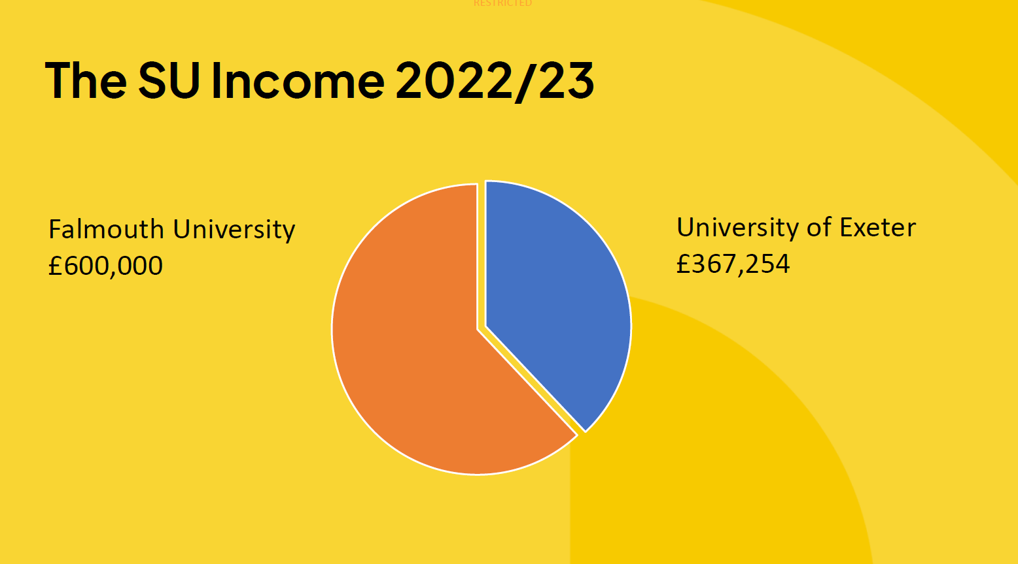
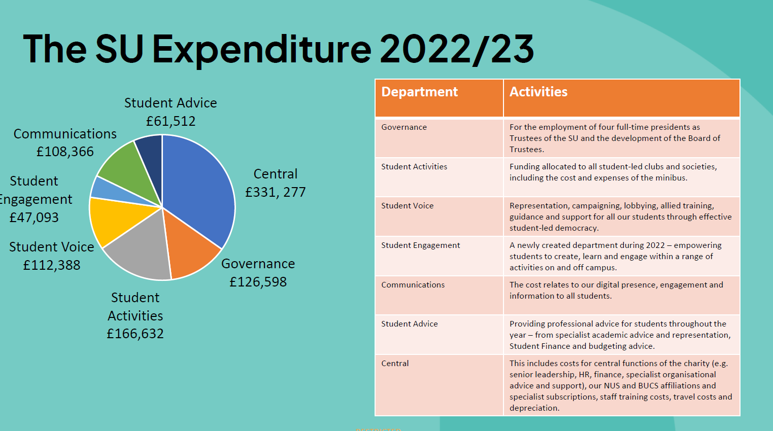
  - Noted: that the latest report is available online at the SU and the Charity Commission.
- List of affiliations 2020/21
  - Approved: the list of affiliations 2022/23 which were National Union of Students (NUS) £20,173 and British Universities & Colleges Sport (BUCS) £2,413.
- Open questions to the Trustees.
  - Noted: that there was an opportunity for any student member to ask a question and there were none.
  - Noted: that the Trustee Report and Accounts are available at the SU – online and in person.
- Meeting Closed

