The Falmouth & Exeter Students’ Union

Students’ Members Meeting
Date | 21 January 2021 | Time | 16:00
Location | Online
Attendance | George Williams (GW) Student Council (Chair)  Cara Chittenden (CC) President Exeter  Lizzy Marshall (LM) President Falmouth  Charlotte Agnew (CA) President Welfare & Inclusivity  Amelia Banton (AB) President Student Experience  Sarah Davey (SD) Chief Executive  Karen Pardoe Project Officer

 | Minute
1 | Welcome from Chair  1.1 Noted: that due to the lockdown restrictions The SU is unable to hold an AGM as set out in its constitution. The Trustees would still like to be able to give members an opportunity to receive the usual business of AGM and this Students’ Members Meeting follows the usual content of an AGM. As this is not an AGM however, no business can be transacted by voting – all items will be noted. There will be an opportunity to ask questions to presidents and others at the end of the meeting.
2 | Minutes of previous AGM (17 February 2020)  2.1 Noted: that the minutes of the previous AGM is available on The SU website.
3 | Receiving the report of the Trustees on the Union’s activities since the previous AGM and receiving the accounts from the previous financial year  3.1 Received: the Trustees Report and Statutory Accounts for year ending July 2020. SD talked through this report.  3.2 Noted: that the full report is available on the website and the Charity Commission. Noted that it was a good audit with no irregularities or non-regulatory issues identified. The report details the objects and how the charity is achieving these as well as demonstrating how the charity meets its Public Benefit test.  3.3 Noted: the SU’s income for 2019/2020 below:  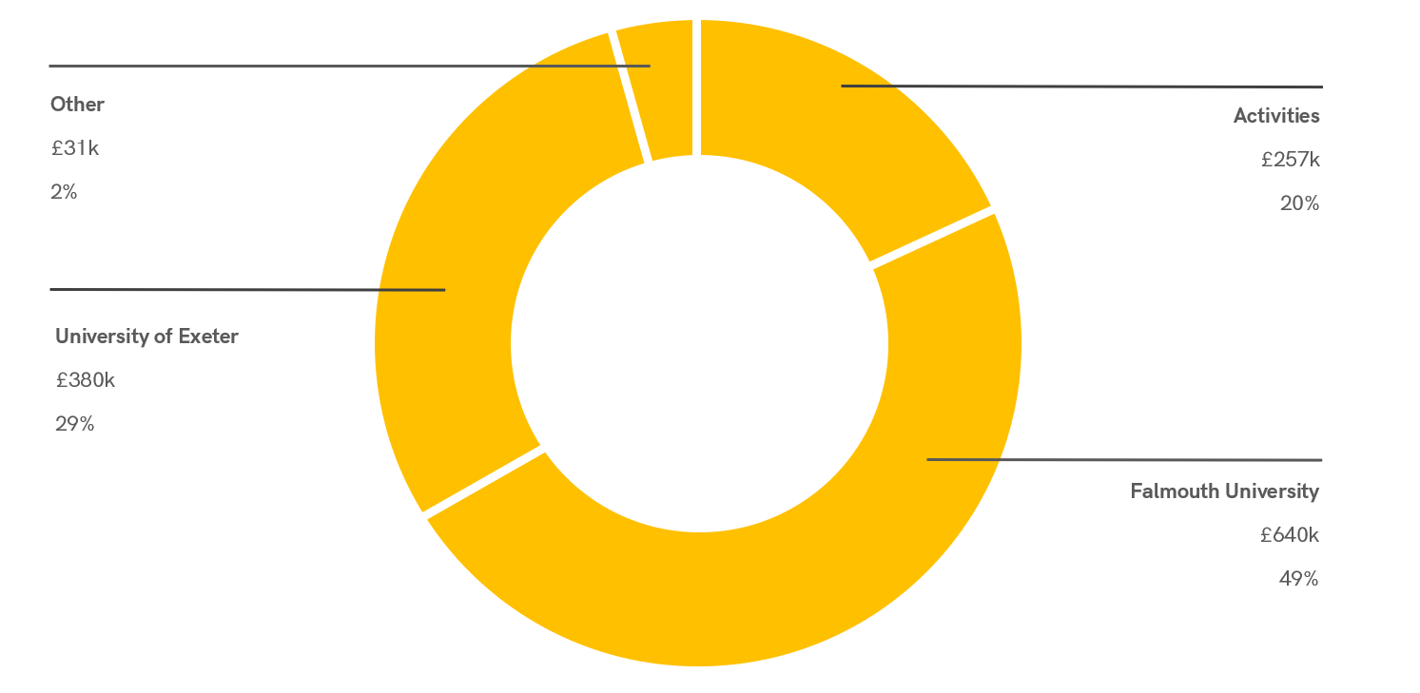  3.4 Noted: the SU’s expenditure below:  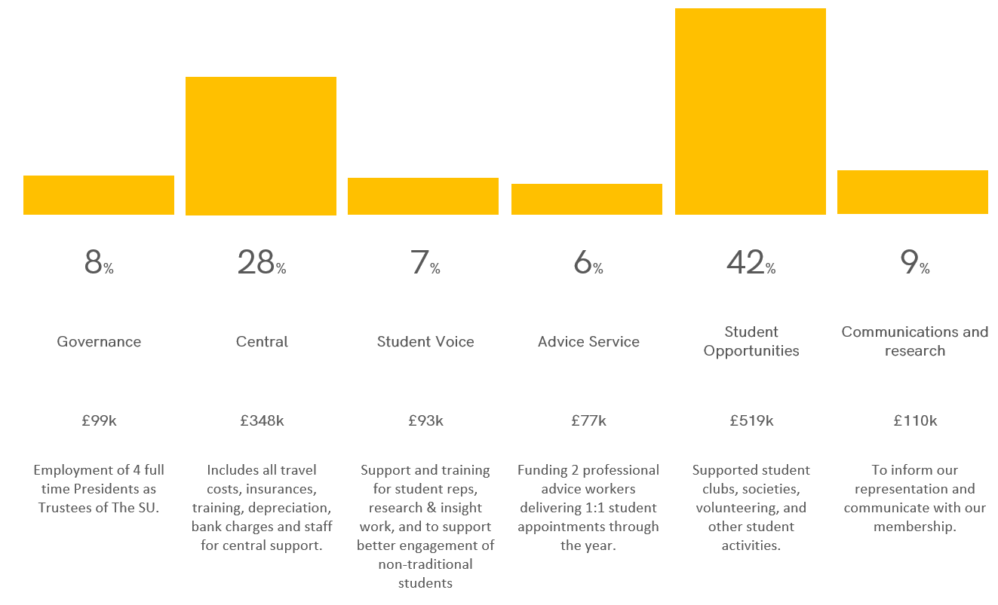
4 | Appointment of the Auditors for 2020-21  5.1: Noted: Lang Bennetts are to be to the auditors to prepare the Financial Statements 2020-2021. These auditors have been used previously and The SU would like to retain them especially as the legal form is changing from Unincorporated Association to Charitable Incorporated Organisation (CIO) this year.
5 | List of affiliations 2019/2020  4.1 Noted: the affiliations for 2019/20 were the National Union of Students (NUS) £20,752 and British Universities & Colleges Sports (BUCS) £1982.
6 | Update from Presidents  6.1 Noted: from Cara Chittenden that:  - Campaign for no-detriment policy to protect student grades. In meetings with the University urging them to increase their mitigation policies to protect student outcomes as well as campaigning with Exeter Guild and Students Academic Mitigation. Co-signatory of a letter to the Russell Group asking them to rethink their blanket stance rejecting an individual no detriments policy. Some progress has been made with the development of the new policy to be more generous with the degree classification.  - Launching a tuition fees campaign with a statement and action plan detailing how the presidents are going to tackle the issue of refunds.  - In regards to the Decolonizing The Curriculum manifesto pledge, CC has created a decolonising the curriculum Steering Committee and designed a survey for all students on their experiences of the curriculum at Exeter’s Cornwall Campus – hoping that each department in Cornwall will create an action plans detailing how they hope to tackle decolonizing the curriculum. Further to this, EDI reps have been recruited and trained in all departments at SSLCs.  - Graduation Ball – AB and CC have confirmed that there is potential for UoE to the set up of the graduation ball for both the 2020 and 2021 cohorts. With LM created what such a ball would look like with external events organisations to support this. Hoping this might still happen.  - Finally postgraduation students have been working on improving how the services of The SU can support post-graduate students including building in better communications and building communities.  6.2: Noted: from Amelia Banton that:  - Sports on campus – Sports Strategy for Exeter is progressing. Slowed up due to the pandemic but has now picked up pace again.  - Events – these have gone online with Native (online events platform) including Harry Potter quiz and more events happening this term.  - Return to Society Activity (in person) – this is in line with Boris’ roadmap.  - Sustainability Week – first week in March. Online campaign, working with Environmental and Ethics Part-Time Officer to deliver events.  - Legends – working with the Volunteer Part-Time Officer to simplify the Legends page to help with logging hours.  - Council – going well. Recruited great people and information is on the website.  - Covid – FX Plus weekly meetings and issue around furlough for students which FX Plus are looking into now.  - Falmouth – pitched to the Falmouth Vice Chancellor asking for a document which outlines the spending on Covid.  - Student Experience Committee – Co-Chair this meeting. Feed into ROS (Rep Online System) and collect this data and present it to the senior people at both universities.  6.3 Noted: from Charlotte Agnew that:  - Private accommodation – letters to various key people including the local MPs and open letter to landlords.  - Equality Diversity and Inclusivity (EDI) – taking to Falmouth University about EDI and set up focus group looking at decolonizing the curriculum for Falmouth.  - Wellbeing of Students – after an SU survey, CA and other presidents were able to present the findings to both universities and they listened. Complex situation and working on campaigns such as no-detriment and rent to support with overall student wellbeing. Further this this, the Together Whether campaign is running and is taking a digital approach along with yoga sessions.  - Wifi Issues – working with part-time officers to feedback issues at Sidings.  6.4: Noted: from Lizzy Marshall that:  - Falmouth have decided on a No Detriment Policy for students this year affected by the pandemic.  - Access to facilities – working with the Falmouth Education Officer and 42 Reps to lobby the university to address this issue after lockdown. Well received by the University. This includes writing to Michelle Donelan too.  - Covid specific breakdown of the fees – working with Falmouth University to produce a report which shows how much has been spent on Covid spending. Talking to student reps about this too.  - Student Voice Representation – ongoing manifesto pledge. Engaging and building a relationship with Fashion & Retail Academy. SSLGs are happening and continue to be informative. Setting up meeting with department reps. Post-graduate representation are more representee with a renewed system of feedback.  - Collaborative community – CoLab has been legally reviewed and will be launched of the 1 February 2020. Department specific CoLab projects with the university. In partnership with Real Works, introducing creativity and innovation week in April.  - Graduation – likely to be September for everyone due to restrictions.
7 | Open questions to the Trustees by the Members.  7.1 Noted: No questions.
8 | Meeting closes

