How to: Record volunteering hours.
Be you a wonderful rep, committee member or any other lovely volunteer, please use the Legends platform to record your activities. What’s in it for you? A Skills Log to help you write your CV, an hours log, and maybe a shiny certificate!

Step 1
Go to: https://www.thesu.org.uk/opportunities/volunteering/

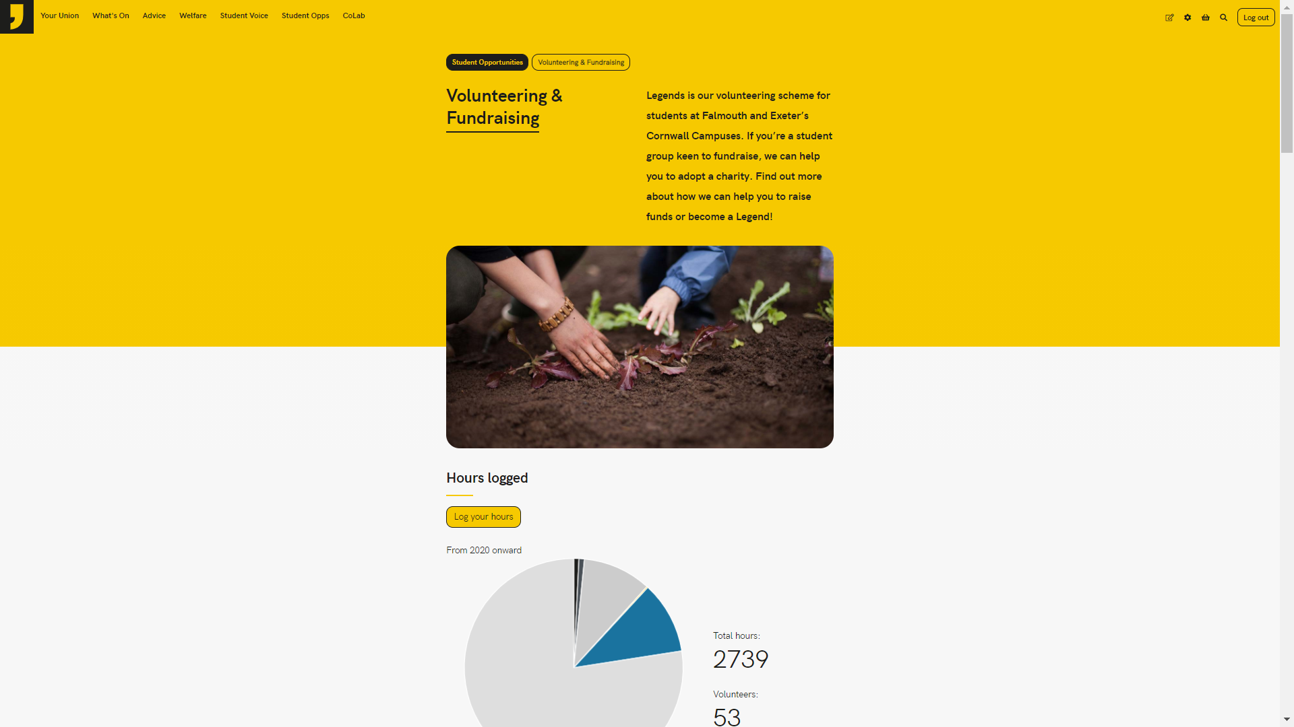
- Make sure you are logged in (top right corner)
- Underneath the picture, click the ‘log your hours’ button. If you have not done this before (quite likely if you are reading this) It will prompt you to set up a profile. Please set up a profile to proceed.
- Once you have set up a profile, log your hours!

Step 2
The ‘Log your hours’ button will bring you to this screen (below) where you can add all of your hours.

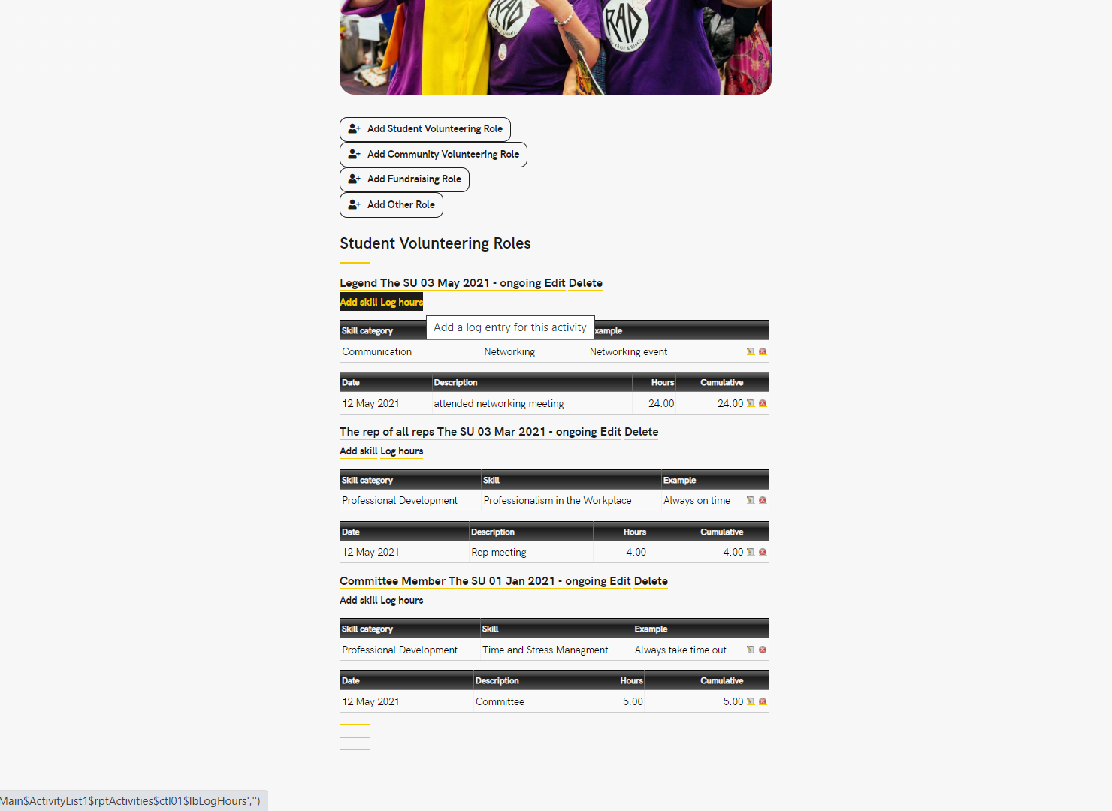
- Add your role(s).
If you are a rep or a committee member, your hours count towards a student volunteering role. If you work with external organisations like the scouts and guides, then your role is more of a community role. If you give your time to fundraise… you get the idea! Any unpaid time you are giving that benefits others counts.
There are no wrong answers here – just pick the title you feel best fits your activity.
- Add Skills gained.
This allows you to identify all the skills you have gained or practised in this role. Be really specific here, it will help you when writing CVs in the future.
- Log hours.
If you don’t want to add 1 hour per week for the last 10 weeks, just add 10 hours at once after you have done them.
It’s good to add little and often – saves a bulk add at the end of the year and is easier to remember. If you’re super organised, maybe set yourself a little calendar reminder to fill it in every month.
Once you have completed all of your hours, you can download an hours log and skills record; and if you record enough hours – a certificate (woo!!)
How to do this:
- Go here: https://www.thesu.org.uk/legends/profile/
The link to this is at the bottom of the volunteering homepage, click the ‘Legends’ button.
- Once here, look for those two magical links in the red circle (as seen below)
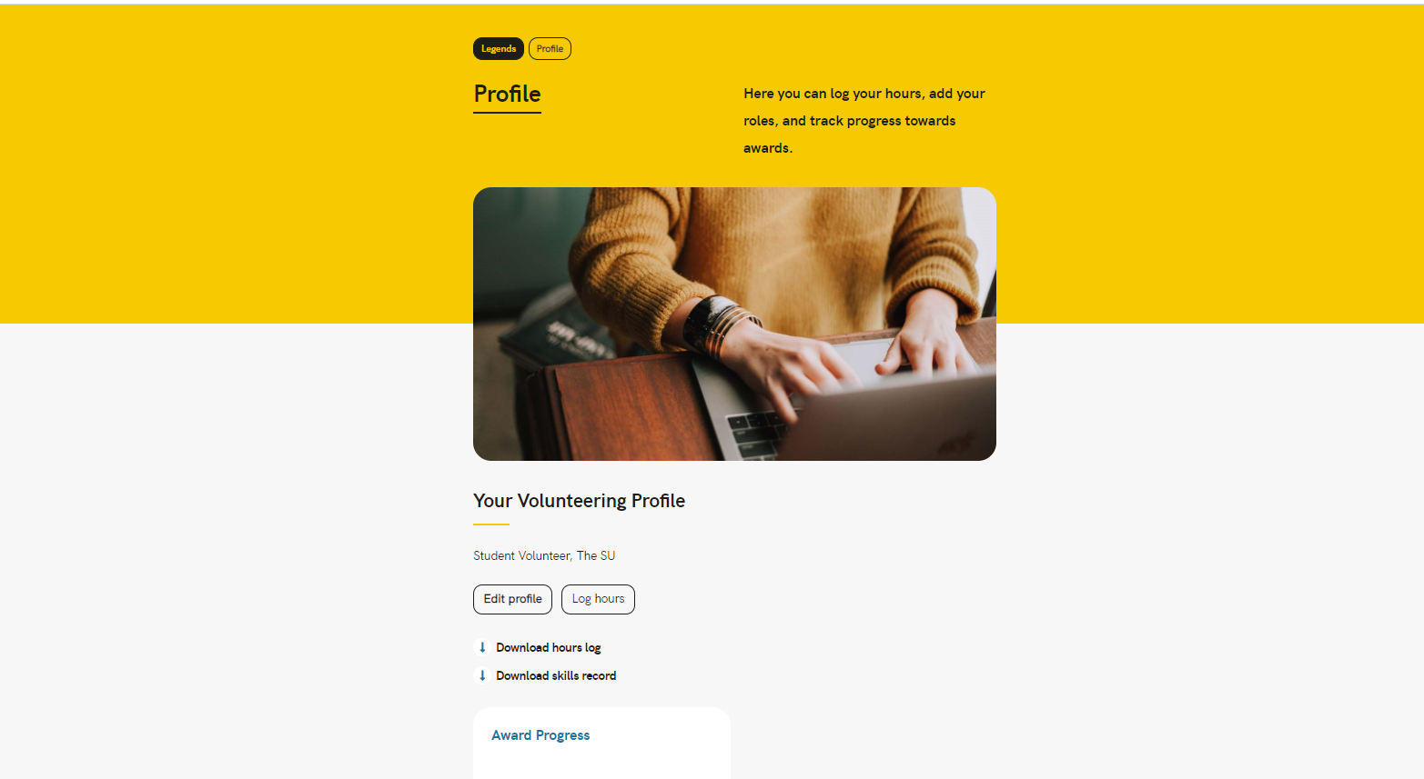
If you continue to scroll down on this page, it will show you your awards progress and - if enough hours have been recorded – a certificate. Who doesn’t love a certificate?! You’re welcome. Happy skills logging!

